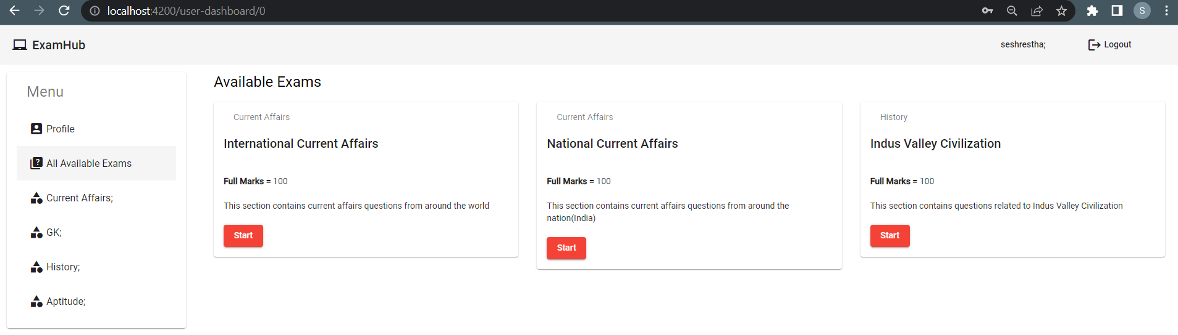

Load-exams.component.html –

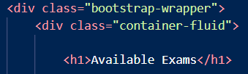

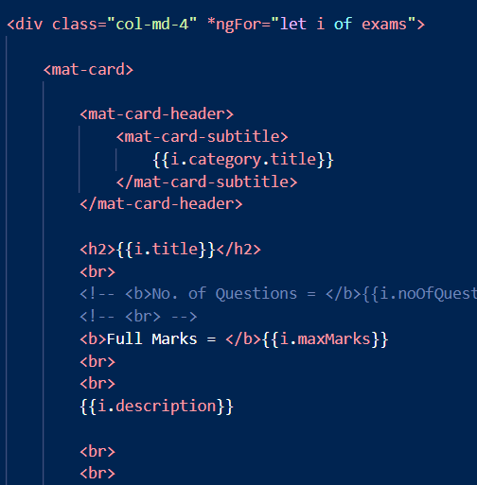



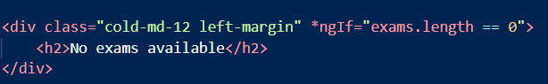

Load-exam.component.ts –

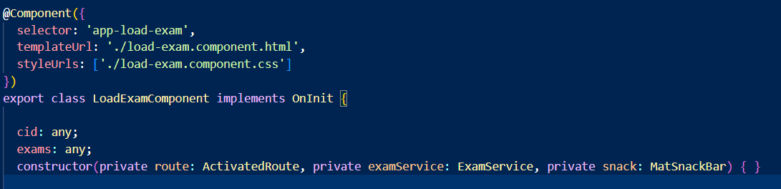

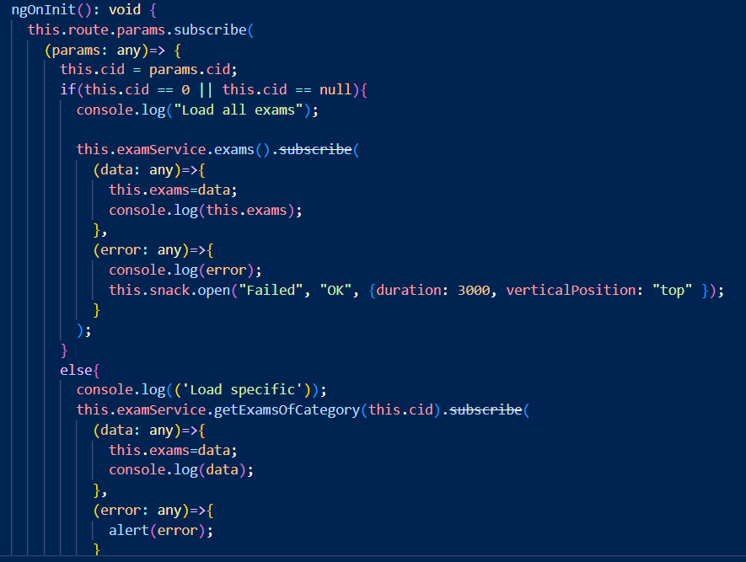

Exam.service.ts –

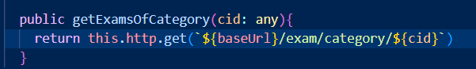

ExamController –

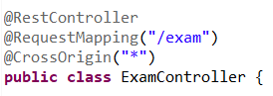

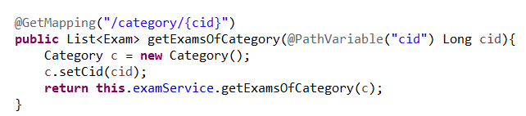

ExamServiceImpl –

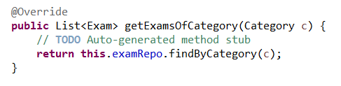

ExamRepo –

